- PURPOSE
Establish a system to purchase quality goods and services from all contractors, suppliers and vendors at the most reasonable prices. Complete and process all paperwork associated with purchases in an accurate and timely manner.

2.0 SCOPE
This procedure describes the method of authorizing for purchase goods, including raw materials, and services for use by all Giles – Waynesville locations

3.0 DEFINITION
Purchase Order - A contractual agreement between a provider of products, materials or services
and Giles Chemical.

4.0 REFERENCE DOCUMENTS DOCUMENT NUMBER
Blanket Purchase Order N/A
Purchase Order (PO) N/A
Receiving Documents N/A

5.0 Procedure
Blanket purchase order (numbers) can be issued for Sulfuric Acid and Magnesium Oxide only. Blanket purchase orders will be valid for purchases in a single, specific month. A unique manual PO number will be issued for each individual supplier. Upon receipt of sulfuric acid and magnesium oxide, a properly completed receiving document must be timely submitted to accounting in order to process the supplier’s invoice for payment. Accounting will verify the supplier’s pricing to approved unit costs supplied by the business manager.

Purchase orders (numbers) will be issued for all purchases, excluding sulfuric acid and magnesium oxide, including but not limited to packaging supplies, equipment, repairs, freight-in, supplies, etc. Purchases will be authorized in strict accordance with the company procedure on “Purchase Authorization Limits”. Only authorized personnel shall authorize the issuance of a purchase order (number). The company uses a manual purchase order system with the yellow copy designated as the accounting copy. The purchase control document(s) shall be submitted to accounting by the close of normal office hours on the day of authorization and shall include the yellow copy of the manual purchase order with all appropriate information, the PO Project Code, if applicable, and a description of the item to be purchased so as to allow for correct cost coding, the vendors part number, if known, as it will appear on the payables invoice, quantity of the individual item to be purchased, the unit price of the individual item to be purchased, the extended price of the individual item to be purchased, explicit delivery terms, (if applicable) delivery cost or an approximation thereof noted and the appropriate approval signature(s). The item description can also be submitted on a purchase requisition form or vendor quote if all appropriate information is included and noted on the face of the yellow PO copy as “SEE ATTACHED”.

A properly executed delivery document is accounting’s verification that the item purchased has been received in good and acceptable condition and that the purchase document(s) can be processed for payment.

6.0 WORK INSTRUCTIONS FOR ISSUING A PURCHASE ORDER

- Manager confirms the need for the purchase
- Manager identifies source(s) for item(s) or services needed
- Managers are responsible for continually looking for more than one quote as well as competitive pricing form other vendors when ever possible.
- A purchase order is to be prepared, completed and distributed in accordance with the following:
  - All purchase authorizations are to be prepared in accordance with the Company’s “Purchase Authorization Limits” procedure.
  - A Manual Purchase Order Number is designated for each purchase. “Verbal”, or any variation thereof, as a PO Number is not permissible.
  - Assign one PO Project code to entire purchase or clearly indicated the PO Project code for each line item.
  - Clearly indicate the shipping/delivery terms. If the exact or approximate amount of shipping charges are not known, shipping amounts up to $150.00 will be paid without additional approval requirements.
  - A separate line must be used for each different item description.
- Appropriate approval signatures are affixed to the purchase document
- Completed purchase document, with required supporting documents, is submitted to accounting by the close of normal office hours on the day the purchase authorization is released.
- For purchases under $500.00 which are ordered and picked up by or delivered to Giles with a final supplier’s/vendor’s invoice in the same day, the invoice, if properly signed by the responsible manager, with the yellow PO copy attached and PO Project Code clearly noted, can be submitted by the close of normal office hours the same day without completing the purchase document. If the invoice is not submitted the same day then all appropriate purchase documents must be completed.
- AP Accounting Associate enters the Purchase Order into Dynamics with PO Project Code as assigned by Manager
- Once Purchase Orders are submitted to accounting the PO cannot be changed (See “Changes”)
  - (Changes to submitted Purchase Orders must follow guidelines under 6.5 on page 3 )
- Ordering Manager is responsible for any follow up calls related to the item
- Ordering Manager will be responsible for accuracy of received items as well as receiving documents
- Ordering Manager will forward a signed and dated receiving document accounting within thirty-six (36) hours of receipt of the item(s)
- After review by an Accounting Associate, the approved receiving document will be matched to the appropriate purchase document for processing.
- Any discrepancies on invoices will be resolved in a timely manner by the AP Associate with timely assistance by the Ordering Manager.
- To aid resolving discrepancies, each manager will have a folder in the Purchase Control Areas of the accounting department that will contain documents needing attention by the issuer. This folder should be reviewed on a regular basis.
- The following items are exempt from a purchase order requirement – pest control, forklift maintenance and repairs, weigh scale calibrations and repair , sludge (mud) disposal, exchange of welding gas cylinders, Lowes credit card charges, BP credit card charges, uniform rental, purchases made in accordance with a contract executed by the President.
- A sample purchase order is appended hereto to be used as a guide when additional documents detailing the purchase are attached to accounting’s yellow copy.

6.5 Changes to Submitted Purchase Orders:

If changes need to be made to a previously submitted purchase order document, adhere to the following steps:

1. Submit the purchase document noted as “REVISED” and the word revised highlighted
2. Highlight the changes made to the original document and the date of the revisions
3. Additional items may not be added as a revision. If additional items are required a new purchase
document and purchase order number is required.
4. Communicate the changes to the vendor so that invoices can be processed properly. Changed items must be
billed by the vendor under the PO# associated with the changes.

Sample Purchase Order
Date of Order

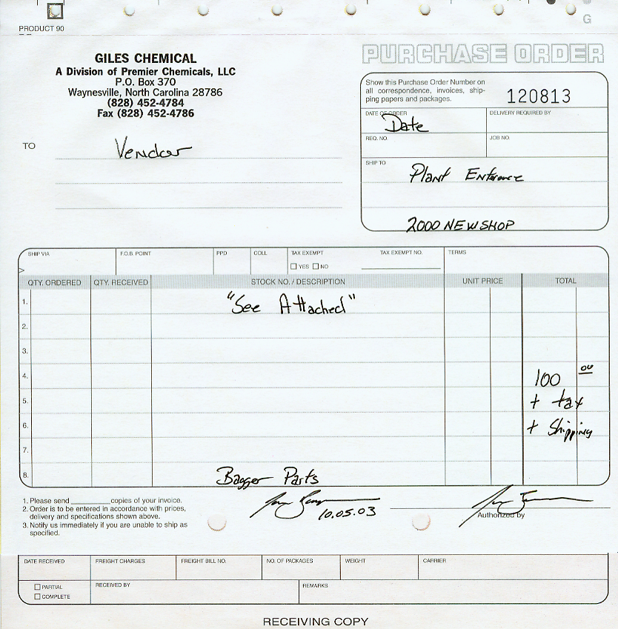
Vendor
Name
Project
Code
“See Attached”
When invoice or quote can be stapled to PO
Brief description if needed
Total cost
or
Subtotal +
Verbiage
( + tax )
( + shipping )
If applicable
Signature
Authorizing signature if needed

